January Holiday Programme 2026 Please see notes below
Mon 12 Jan | Tues 13 Jan | Weds 14 Jan | Thurs 15 Jan | Fru 16 Jan
Welcome Back, relax at the pool  Make ice cream cone faces  Make your own scratch paper   | Water slide  3D Summer craft options  Painted Stones   | Colourful Caterpillars    Scavenger Hunt  Water balloons!  Fish and Chips lunch - optional | Water fight – bring a plastic container from home!  Fish and chips Top of Form  Bottom of Form  Decorated glasses - design competition   | Bring your snorkel if you have one!  Group Quiz –Will your team win?  Magic Trick craft  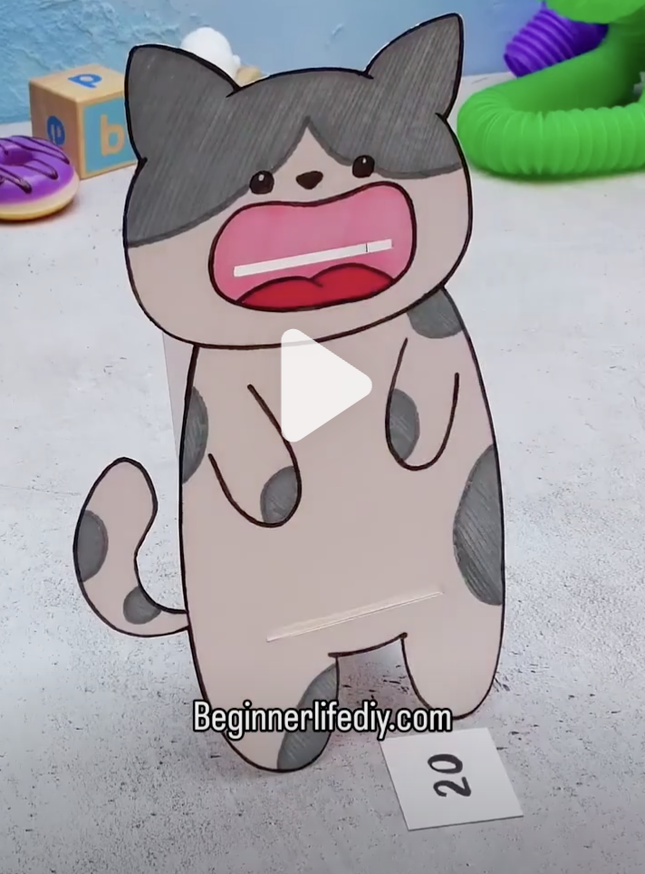
Mon 19 Jan | Tues 20 Jan | Weds 21 Jan | Thurs 22 Jan | Fri 23 Jan
Water Slide Fun!  Card Tube Dogs    Farmer, Farmer | Optional pizza lunch  Stitch craft – stencil a design then stitch around it    Pool fun! | Margaret Mahy Park  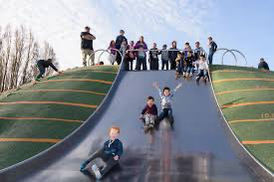  Trip fee $12  Bus leaves 10.30  Back for a swim!  Pick a craft project | Silverstream Alpaca Farm  Tour  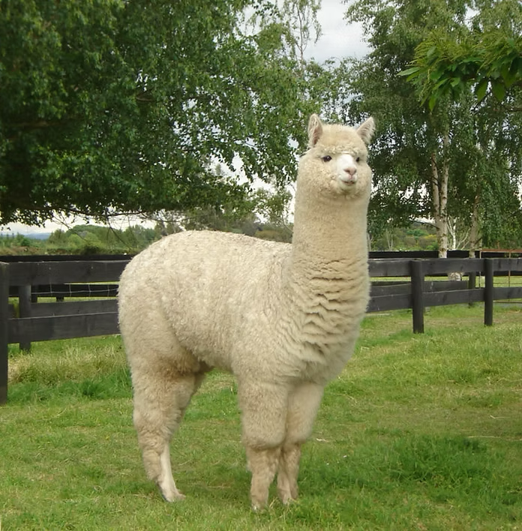  Trip fee $15  Bus leaves 10.00  Back for a swim! | Mr Whippy –TBC Please bring $5 to contribute to this – Oscar will pay the rest  Facepainting  Make a 3D Ice cream van  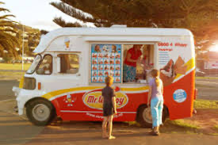
Mon 26 Jan | Tues 27 Jan | Weds 28 Jan | Thurs 29 Jan | Fri 30 Jan
Cany floss machine  Act fee: $5  Face Painting  Egg carton craft | Buskers and Botanical Gardens pool and playground  Pack your togs!  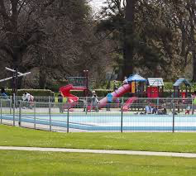  Trip fee $12  Bus leaves 10.30 | Make your own scratch paper  Pick a project  Capture the Cones | Optional fish and chips lunch  Treasure Hunt! Work out the clues and find the treasure  Water Slide | Inflatable fun onsite for the day – Extreme II Obstacle Course  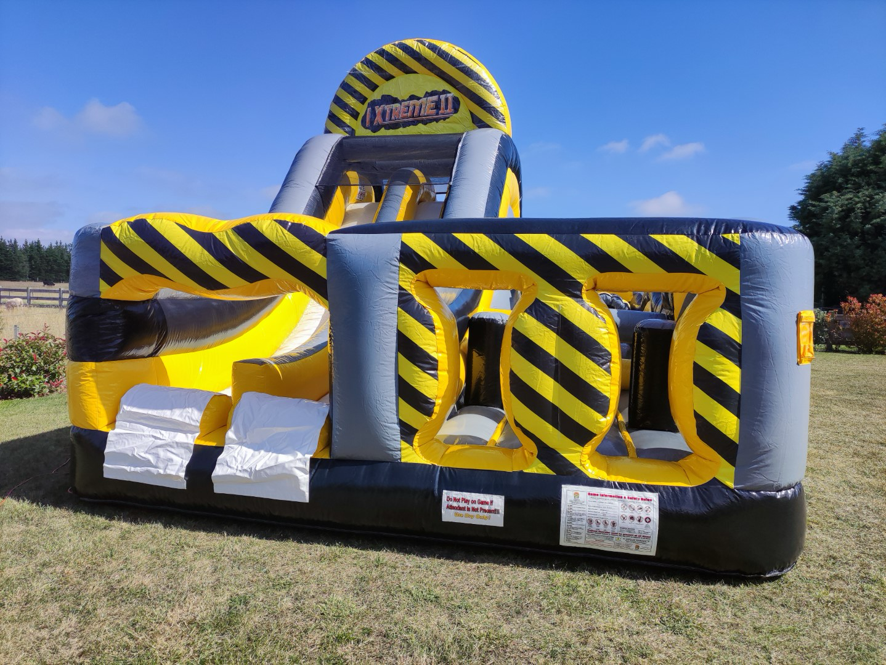  Act fee $12  Fun at the pool  Games in the hall
Mon 2 Feb | Tues 3 Feb
Relax at the pool before starting school!  Today is a relaxed Oscar play day  Bingo Game  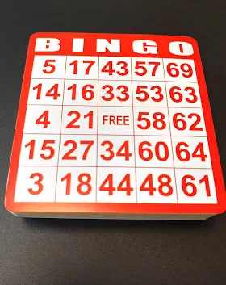 | School starts  
Notes:
- The 3 week holiday programme this year is a trial – normally we only do 2 weeks, but this year we will try 3 weeks in January and 1 week in April as the April holidays are usually so quiet
- The holiday hours are 8.30am-5.30pm
- Fees for the day are currently $51 until 3pm and $55 up to 5.30pm. For the $51 rate to apply please collect your child by 3.00pm.
- Please – once you have booked you need to make payment to: 38-9014-0645118-00 Mt Pleasant Oscar Ltd
- We do charge an activity fee and this is usually $12 however, the Alpaca Farm day we need to charge $15 for that day. I think the kids will love this trip but they charge us $20pp and the bus will be approx. $17 pp so it is an expensive day. Days with activity fees are: Week 1 – none, Week 2 Weds 21/1 Margaret Mahy Park $12, Thurs 22/1 Alpaca Farm Day $15, Fri 23/1 Mr Whippy $5 (Oscar will pay the top up), Week 3 Monday 26/1 Candy floss $5, Tues 27/1 Buskers $12 and Fri 30/1 Inflatable $12.
- Buses will leave at the following times: Weds 21/1 10.30am, Thurs 22/1 10.00am, Tues 27/11 Buskers 10.30am. All our trips/activities are dependent on the weather!
- On the following days there is the option to buy lunch: Weds 14/1, Tues 20/1, Thurs 29/1. Please bring cash for this – we will have change. Adding on to the programme fee just makes it too hard for me to track. The current price for pizzas at Dominoes is $7 and we will send home a link to the fish and chip shop the night before for those orders.
- Please make sure the kids have water bottles and sunhats – this is really important
- Please make sure there is a top with long sleeves in case we are out and it turns cold
- If your child has a particular sunscreen, please pack it for them
- Bring togs/towel/goggles each day – or a change of clothes so the kids can cool off
- If you are using the Oscar subsidy, please ensure I have received the forms for this. If you need forms, please let me know as I do have some. Not sure if you qualify for a subsidy? Check here: https://www.workandincome.govt.nz/map/deskfile/extra-help-information/childcare-assistance-tables/oscar-subsidy-current.html
- As per our policies, enrolment information and enrolment forms – we do charge for absences
- On the Margaret Mahy Park day – we will have the 5 and 6 year olds in a couple of groups with a staff member, and they will move as a group together around the park. They won’t be able to run off and just play anywhere. Definitely bring a change of clothes that day as the kids have a great area for water fun. We will have other staff roaming the playground, watching the kids and another staff member at a table with our bags so the kids always know where they can find someone
- If your child is unwell – please don’t bring them to the programme
- If your child behaves in a way that puts themselves or others in danger or is behaving in a way that another person’s enjoyment is being affected, we will warn them but after this we will phone you to collect your child. A refund will not apply – please talk to your child about following the instructions of our staff
- The kids get a bit hungrier than usual in the holidays so please pack an afternoon tea for them – they are usually pretty active throughout the day
- You can book by emailing Kath at markath@xtra.co.nz - we are unable to ‘pencil in’ bookings

