January Holiday Programme 2024 – Mon 15 Jan – Weds 31 Jan (13 days)More notes overpage
Mon 15/1 | Tues 16/1 | Weds 17/1 | Thurs 18/1 | Fri 19/1
Mould and paint magnet crafts  School Pool  Games in the hall  Gaga Ball in the pit! | Pizza lunch available  Scavenger Hunt  School Pool  Games in the hall  Dodgeball  Inflatable dingy for water play | Jellie Park – Hydroslide for older kids and indoor little pool for our younger kids  Musical Statues  Gaga Ball in the pit!  Bus leaving 11.10am | Bishopdale playground and scooter park – with obstacle course. Must bring safety gear if scootering  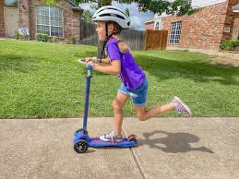  Bus leaving 10.30am | Sno Cone machine hired today!  Water slide  School Pool  Games in hall  Spin the bottle  New game Kiwi Slam  Lego masters – robot theme  Lily pad tag!
Mon 22/1 | Tues 23/1 | Weds 24/1 | Thurs 25/1 | Fri 26/1
Orana Park  Come and have lunch with the animals!  Offsite till 3pm  School Pool  Bus leaving 9.45 am | Candy floss  Machine hired today!  Water fight  School Pool  Hide and Seek | Fish and chip lunch available  School Pool  Games in hall  New game – Kiwi Slam  Gaga Ball in pit! | Day at Botanical Gardens – playground, paddling pool climbing tree and Buskers  Bus leaving 10.00am | Water Slide  School Pool  Games in the Hall  Marco Polo  Gaga Ball!
Mon 29/1 | Tues 30/1 | Weds 31/1
Inflatable - onsite  Optional pizza lunch  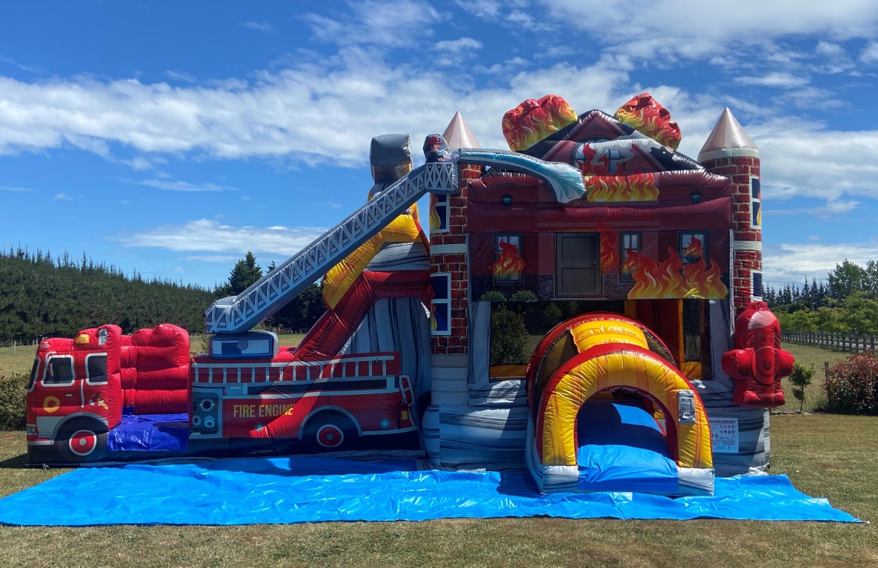  School pool  Pick a craft project  Game – Around the World | Popcorn machine coming to Oscar  Relax and play or pick a craft project from earlier in the programme  School Pool | Make your own lunch  Relax and play or pick a craft project from earlier in the programme  School Pool  Gaga Ball!
Fees and booking:
- $49.00 8.30-3.00 plus $10 for trip day or entertainment hire (Weds 17/1, Thurs 18/1, Mon 22/1, Thurs 25/1, Mon 29/1, $5 extra for Fri 19/1, Tues 23/1, Tues 30/1)
- $53.00 8.30-5.30 plus $10 for trip day or entertainment hire (Weds 17/1, Thurs 18/1, Mon 22/1, Thurs 25/1, Mon 29/1, $5 extra for Fri 19/1, Tues 23/1, Tues 30/1)
- Bookings can be made by emailing Kath at markath@xtra.co.nz
- Once booked – we do charge for cancellations and absences
- Please check here to see if you are eligible for the Oscar subsidy: https://www.workandincome.govt.nz/map/deskfile/extra-help-information/childcare-assistance-tables/oscar-subsidy-current.html
- Payment is requested at the time of booking (unless you are using the subsidy)
- Payment can be made to Mt Pleasant Oscar 38-9014-0645118-00
- Optional fish and chip and pizza lunch is cash on the day please. We will send out food options the day before
What to bring:
- Packed lunch – please remember the kids seem to be more hungry on full days at Oscar
- Water bottle and jacket – especially on outing days
- Togs, towels, goggles or change of clothes as we will likely get wet on hot days
Other information:
- Please inform us if there are any issues to be aware of – medications, custody etc
- We can’t hold a bus up if you are late – please check bus departure time
- Please ensure we know your latest contact details and those of your emergency contacts
- If your child needs a specific sun block – please send it with your child
- Please pack a sunhat for your child
- Rash tops are great for the pool
- If a child’s behaviour repeatedly impacts negatively on others, we will need to contact you to collect your child. We do not give a refund for this
- The holiday programme brochure will be emailed out next week
- Please don’t bring a sick child to the programme

