Mt Pleasant Oscar January Holiday Programme 2025
Mon 20/1 | Tues 21/1 | Weds 22/1 | Thurs 23/1 | Fri 24/1
Welcome Back Day – a day to relax, swim and play with a couple of competitions   | Our own water slide and Candy Floss machine +$5   | Inflatable Fun – The Oasis water slide!  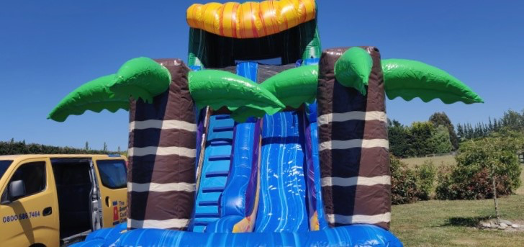  +$10 | Water fight (please bring plastic container or water gun), Face painting  Optional pizza lunch $7   | Margaret Mahy Park picnic lunch and play  +$10  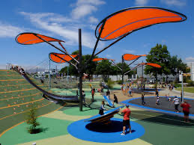
Mon 27/1 | Tues 28/1 | Weds 29/1 | Thurs 30/1 | Fri 31/1
Have a laugh at the city Buskers!  +$10   | Pool day  Optional fish and chip lunch  Mt Pleasant Traitors   | Wet day – School pool, water fight (bring plastic container or water guns)  Scavenger Hunt   | Escape Room  The Cursed Treasure  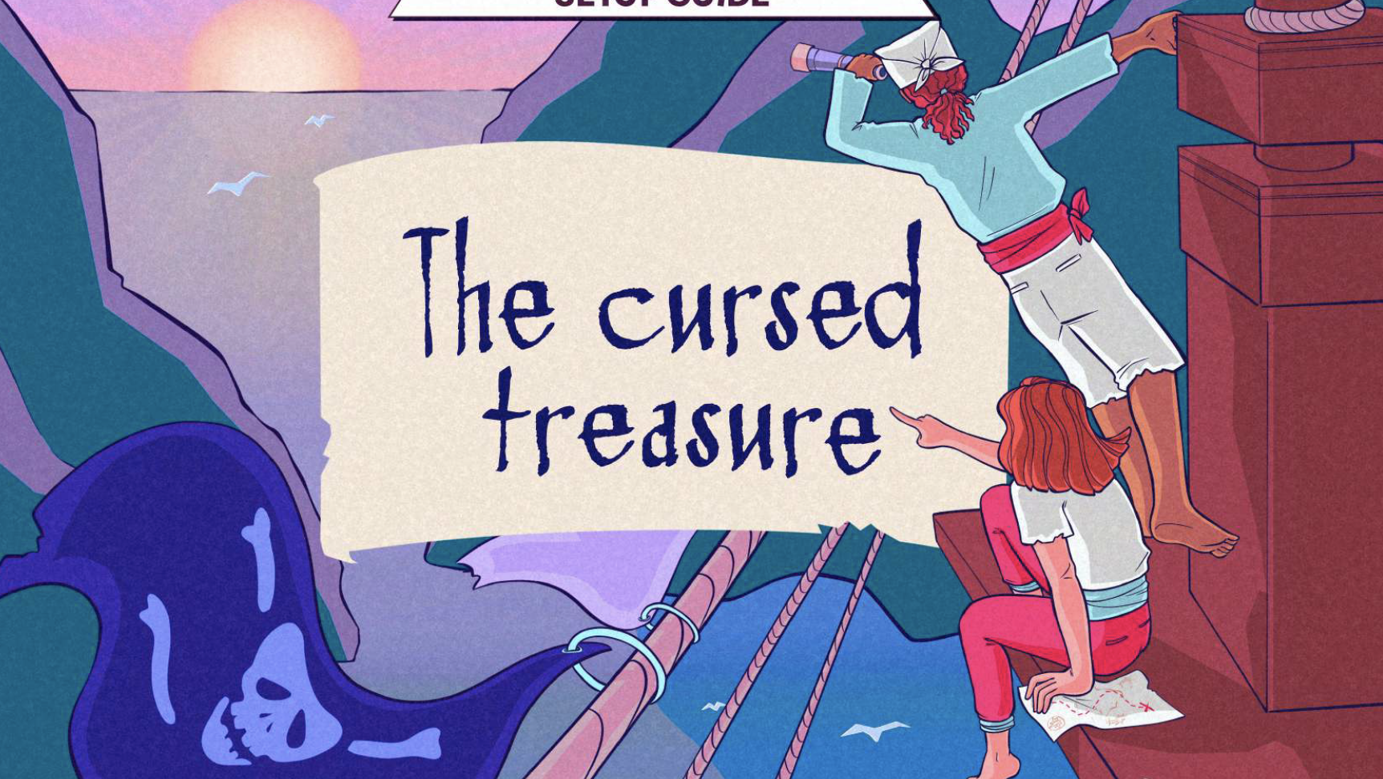 | Movies at the Palms  Mufasa  
Mon 3/2 | Tues 4/2 | Weds 5/2 | Thurs 6/2 | Fri 7/2
  Making Sno Cones |   Make your own lunch day! |   Relax, swim, play, create,  Optional pizza lunch $7 | Waitangi Day No Programme | School starts
The Details:
- Please – once you have booked you need to make payment to: 38-9014-0645118-00 – please note we do charge for cancellations
- Cost per day for the January Holiday Programme is $49 per child until 3.00pm and $53 per child until 5.30pm plus an extra trip or activity fee on the following days: Tues 21/1 +$10, Weds 22/1 +$5, Fri 24/1 +$10, Mon 27/1 +$10, Fri 31/1 +$10
- The cost of make your own lunch is covered by us but we don’t have gluten free bread so if your child is gluten free you may need to supply this please
- Pizza and fish and chip days are optional – pizzas are currently $7 each from Dominoes and I will send the fish and chip options out the night before fish and chip lunch day
- We have a lot of wee ones so on the day of Margaret Mahy – our youngest children will move as one group around the park and have 2 staff with them
- If your child is unwell – please don’t bring them to the programme
- If your child behaves in a way that puts themselves or others in danger or is behaving in a way that another person’s enjoyment is being affected, we will warn them but after this we will phone you to collect your child. A refund will not apply – please talk to your child about following the instructions of our staff
- Fior the $49.00 rate to apply please collect your child by 3.00 pm
- Our earliest bus leaves at 9.15 am and this is Friday 31/1. Please be here in time for this as we cannot hold up the bus. The other 2 buses leave mid morning – 10.30 am
- If you have specific sun screen you want your child to wear, please let us know and supply in their bags
- Please bring water bottles – especially on trip days as we can’t guarantee we can get to a water fountain
- Please bring a sunhat to the programme everyday
- Please bring togs, towel and goggles (if used) everyday and if you have a rash top that is ideal!
- Please make sure there is a top with long sleeves in case we are out and it turns cold
- The kids get a bit hungrier than usual in the holidays so please pack an afternoon tea for them – they are usually pretty active throughout the day
- You can book by emailing Kath at markath@xtra.co.nz

