July Holiday Programme 2026
Mon 6 July | Tues 7 July | Weds 8 July | Thurs 9 July | Fri 10 July
Bring your wheels (and helmet) day!  Chalk cities and Scooter cops and Robbers    Wire weaving fish   | Fish and Chip lunch  Wool dogs  Cotton Tip Darts   | Shoe Box Diaramas choose from some of our scenes or make up your own!    Bingo!  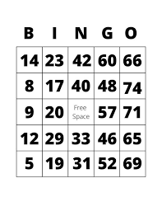 | Icing paw print biscuits!    Matariki star embroidery   | Matariki Holiday  No Oscar today
Mon 13 July | Tues 14 July | Weds 15 July | Thurs 16 July | Fri 17 July
Pokémon Day  Make stuffed Pokémon, Pokémon Treasure Hunt, Stitch craft Pokémon   | Pizza Lunch  Mt Pleasant Traitors Game  Pixel Art     | Movies (Sumner)  Toy Story 5 and free popcorn!    Bus leaves: 9.45am  Lego Masters!   | Make Fudge slice for afternoon tea    Hairy Things!  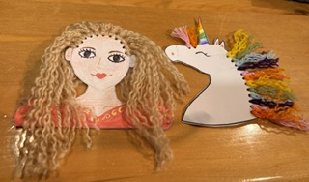   | Kid’s Theatre – Puss in Gumboots!  Bus leaves 10.00am  Group games, Crafts, pick an easy project
Notes:
- The holiday hours are 8.30am-5.30pm
- Fees for the day are currently $51 until 3pm and $55 up to 5.30pm. For the $51 rate to apply please collect your child by 3.00pm.
- Please – once you have booked you need to make payment to: 38-9014-0645118-00 Mt Pleasant Oscar Ltd – put your child’s name as a reference
- We do charge an activity fee of $12 and this will be for Wednesday 15 July for the trip to the Movies (Sumner) and Friday 17 July for the trip to Kid’s Theatre – Puss in Gumboots (Little Andromeda Theatre)
- The bus will leave 9.45 am on Wednesday 15th July and 10.00 am on Friday 17th
- You are welcome to bring scooters any days but kids must have a helmet. We have a scooter day on Monday 6th July
- Optional pizza and fish and chip lunch days: Please bring cash on those days. Pizzas are now $7.50. We will have change on the day if you need it. We will send out the fish and chip menu the night before so you can sort what you want to order
- Please make sure the kids have water bottles
- Please make sure there is a top with long sleeves in case we are out and it turns cold
- If you are using the Oscar subsidy, please ensure I have received the forms for this asap. If you need forms, please let me know as I do have some. Not sure if you qualify for a subsidy? Check here: https://www.workandincome.govt.nz/map/deskfile/extra-help-information/childcare-assistance-tables/oscar-subsidy-current.html
- As per our policies, enrolment information and enrolment forms – we do charge for absences
- If your child is unwell – please don’t bring them to the programme
- If your child behaves in a way that puts themselves or others in danger or is behaving in a way that another person’s enjoyment is being affected, we will warn them but after this we will phone you to collect your child. A refund will not apply – please talk to your child about following the instructions of our staff
- The kids get a bit hungrier than usual in the holidays so please pack an afternoon tea for them – they are usually pretty active throughout the day
- You can book by emailing Kath at markath@xtra.co.nz - we are unable to ‘pencil in’ bookings.

