October Holiday Programme 2024 – Mt Pleasant Oscar
Mon Sep 30 | Tues Oct 1 | Weds Oct 2 | Thurs Oct 3 | Fri Oct 4
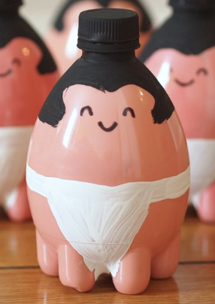  Plastic bottle Craft – make Sumo wrestlers | Fish and Chip lunch - optional  ‘The Firm’ Olympics  “What’s in the Box?’ Game   | Air Force Museum – Bus leaves 9.15am  Make flight models to test   | Linwood Pool  Arrive 12.45 swim 1-2.30  Bus leaves 12.15pm  Air fuelled Straw Rockets   | Scavenger Hunt – identify the pics  Lego Challenge – Animal theme – My pet ….  
Mon Oct 7 | Tues Oct 8 | Weds Oct 9 | Thurs Oct 10 | Fri Oct 11
Make mini cardboard furniture  Group game ‘Mafia’  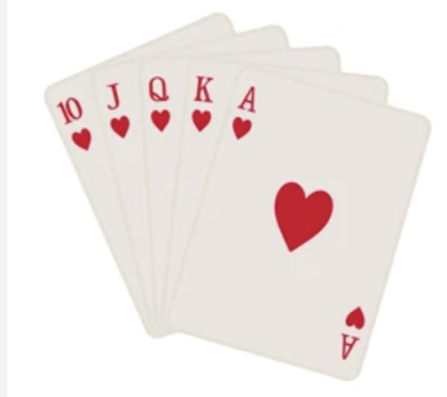 | Pizza Lunch - optional  Discover the art of Quilling  Newspaper hut making challenge  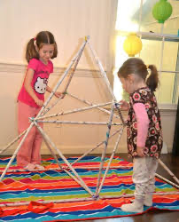 | Inflatable Onsite  Ninja paper  Boomerangs   | Plastic bottle craft – make a Halloween Basket  Make ‘blood and guts’ dessert  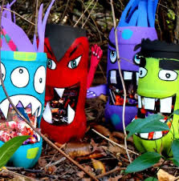 | Movies @ The Palms and ice cream cone from McDonalds  Bus leaves approx. 9.30am  

Fees and booking: - Please note: Kids movie playing – Despicable Me 4
- $49.00 8.30-3.00 plus $10 for entertainment days – Week 1 Weds 2nd October, Thurs 3/10. Week 2 Weds 9 Oct and Fri 11 Oct.
- $53.00 8.30-5.30 plus $10 for entertainment days – Week 1 Weds 2nd October, Thurs 3/10. Week 2 Weds 9 Oct and Fri 11 Oct.
- Bookings can be made by emailing Kath at markath@xtra.co.nz
- Once booked – we do charge for cancellations and absences
- Please check here to see if you are eligible for the Oscar subsidy: https://www.workandincome.govt.nz/map/deskfile/extra-help-information/childcare-assistance-tables/oscar-subsidy-current.html
- Payment is required at the time of booking (unless you are using the subsidy)
- Payment can be made to Mt Pleasant Oscar 38-9014-0645118-00
- Optional fish and chip and pizza lunch is cash on the day please – fish and chip menu here: https://redsnapperseafoods.co.nz/menu/
What to bring:
- Packed lunch – please remember the kids seem to be more hungry on full days at Oscar
- Water bottle and jacket – especially on outing days
- On Mon 30th Sept if you have empty 1 ¼ litre plastic bottles with lids please
Other information:
- Please inform us if there are any issues to be aware of – medications, custody etc
- We can’t hold a bus up if you are late – please check bus departure time
- Please ensure we know your latest contact details and those of your emergency contacts
- If a child’s behaviour repeatedly impacts negatively on others, we will need to contact you to collect your child. We do not give a refund for this
- Please don’t bring a sick child to the programme
- Children can bring spending money to eg, the movies but items are so expensive there… a lot of kids bring something from their lunch box to nibble on or some home made popcorn
- Movie to be confirmed. There are 4 playing and we will see who is booked in to decide which movie
- THANKS TO MSD FOR OSCAR FUNDING

